**SDS REPORT**

**TITLE: FLASHCARD APPLICATIONS**

**SUBMITTED BY:**

BHUVANA I

ATHITHYAA R

**DECOMPOSITION DIAGRAM**

The following decomposition diagram represents the components of the Flashcard Application Educational Website.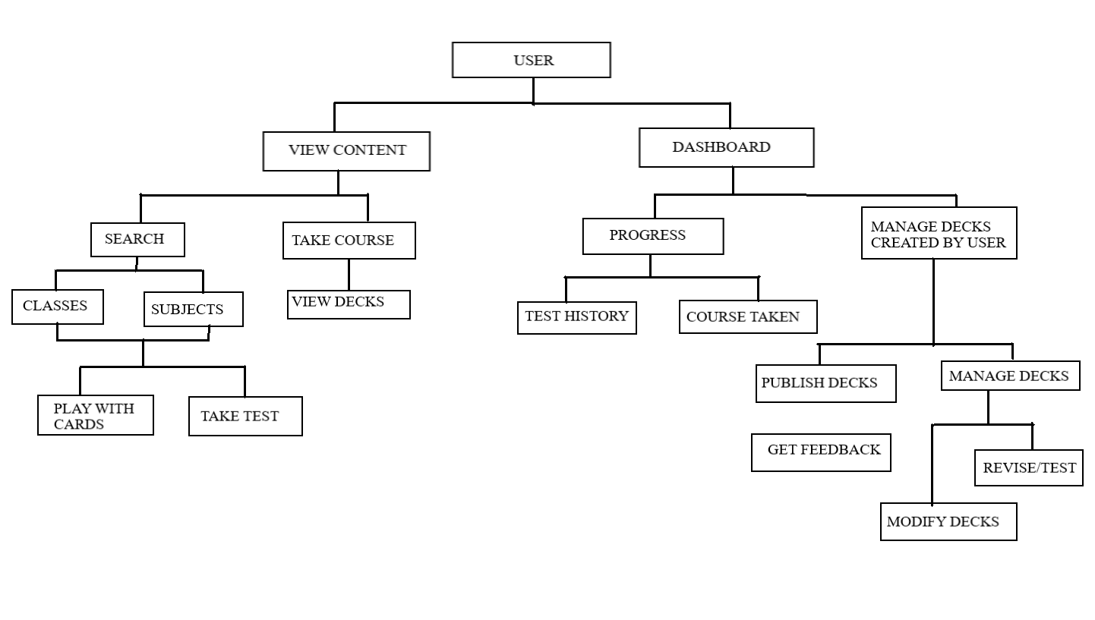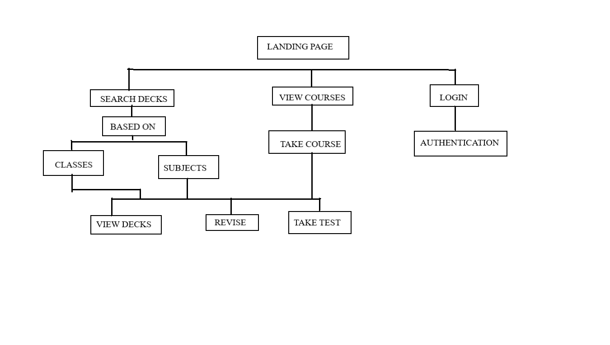

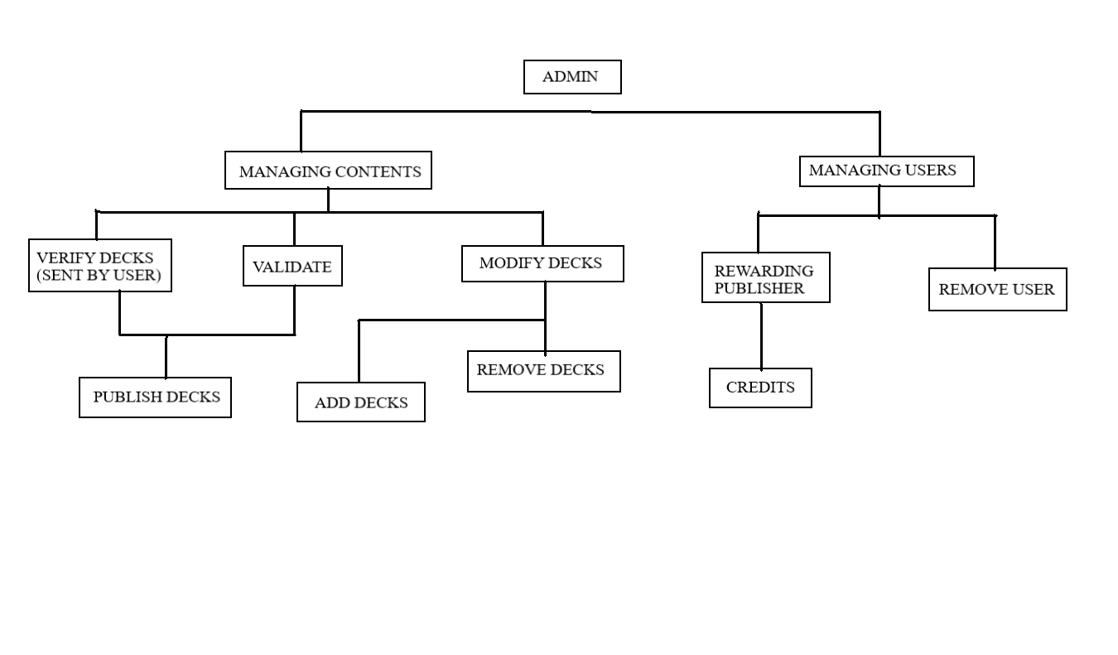

**TIME SCHEDULING**

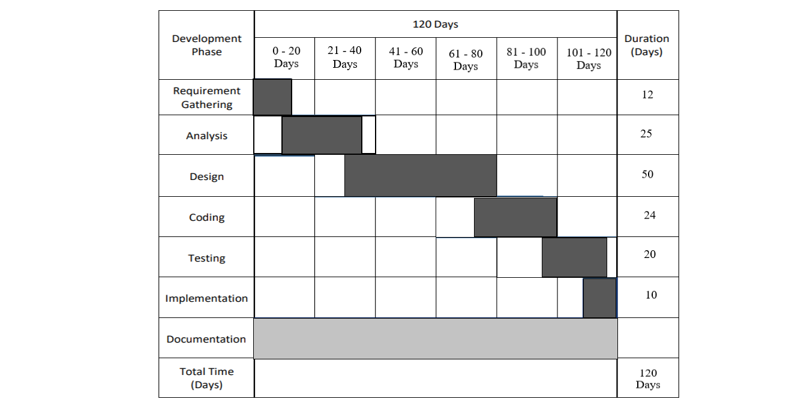

**COST ESTIMATION:**

A cost estimation table lists the expected costs associated with the project. It includes the costs of personnel, hardware, software, and other resources required to complete the project. The cost estimation table for the Flashcard Application Educational Website:

**ACTIVITY CHART**

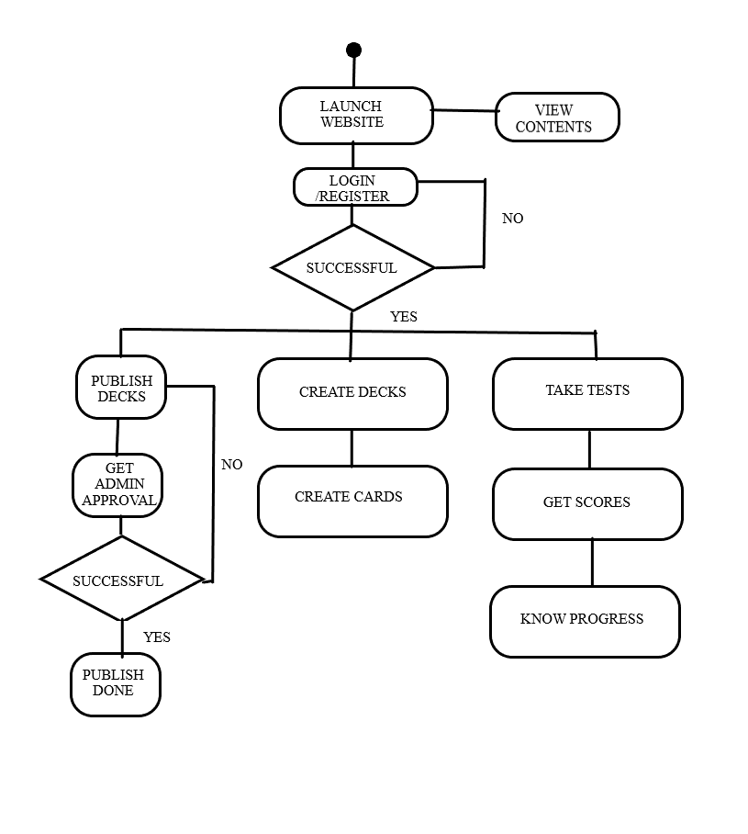

**TASK DEPENDENCY:**

A task dependency table lists the tasks in the project and their dependencies. This helps to ensure that tasks are completed in the correct order and that there are no delays in the project schedule.

Task 1 – Create decks in Landing page

Task 2 – Create decks for users

Task 3 – Publish decks

Task 4 – Approval from admin

Task 5 – Take tests

Task 6 – Get scores

Task 7 – Progress report

TASK DEPENDENCY:

|  |  |  |
| --- | --- | --- |
| **TASKS** | **DURATION DAYS** | **DEPENDENCIES** |
| **1** | 10 | - |
| **2** | 7 | - |
| **3** | 7 | T1, T2 |
| **4** | 8 | T1, T2 |
| **5** | 10 | T2 |
| **6** | 5 | T2, T5 |
| **7** | 10 | T5, T6 |